2.a Fetch customers with multiple orders using joins

select c.customer_Id,c.cust_first_name,c.cust_last_name,c.cust_mobile_number,c.cust_email,o.orderId from Customer_Information c inner join OrderByCustomer o on c.customer_Id=o.customerId where customerId in(select customerId from [OrderByCustomer] group by customerId having count(customerId)>1) ;

2.b Find product details present in cart.

select * from CartDetails

select productId from CartDetails group by productId

select * from Product where product_Id in (select productId from CartDetails group by productId)

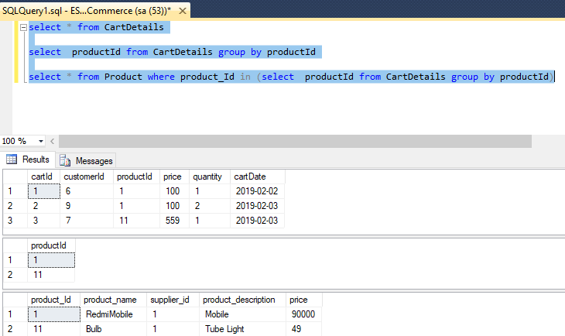

2.c Find distinct customers who have made multiple orders.

select distinct(c.customer_Id),c.cust_first_name,c.cust_last_name,c.cust_mobile_number,c.cust_email
from Customer_Information c inner join OrderByCustomer o on c.customer_Id=o.customerId
where customerId in(select customerId from [OrderByCustomer] group by customerId
having count(customerId)>1) ;

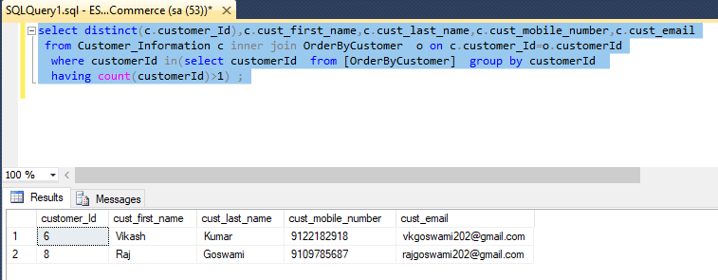
2.d Find distinct Orders made by multiple customers

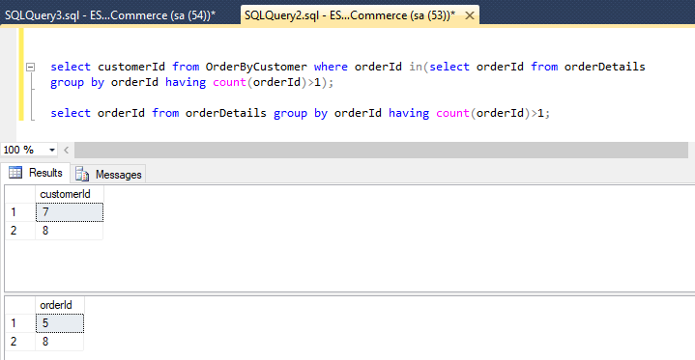

3. Explore in-Build functions(String, etc.), Aggregate functions.

Min(),Max(),Avg(),Sum()
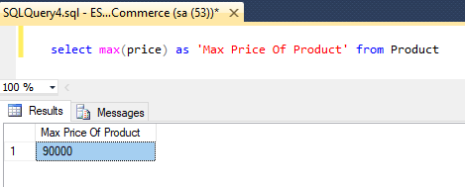

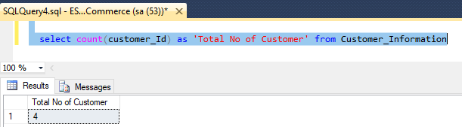

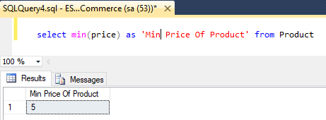

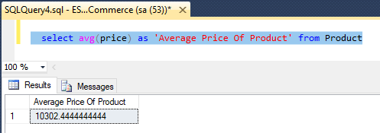

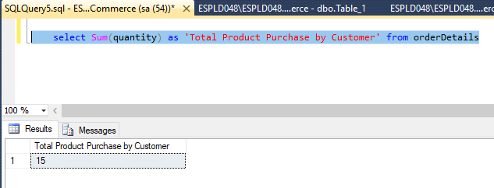

4. Apply indexing for all the tables and examine query plan.(Can take screenshots of the results)

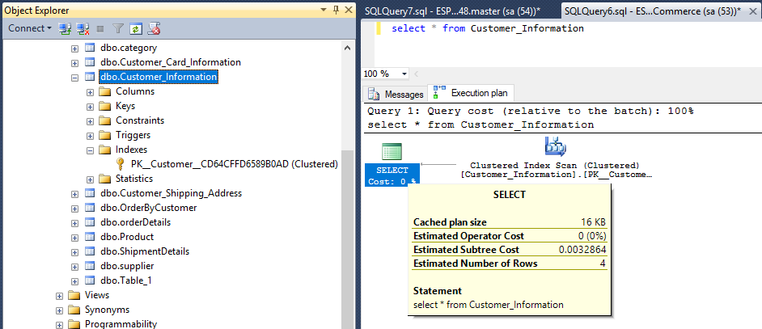
by default index is cluster on Id and it take less time for execution
Now for applying the non cluster index on the table firstly we have to drop the index.
DROP INDEX IX_Customer_Information.index_name;

Now we create the non cluster index on mobile
